FTC Team 519 Epsilon Delta Too
Team Handbook 2018-2019
Herndon High School

Last date of revisions:
8/22/2018

Table of Contents
Purpose 3
About F.I.R.S.T. 3
Goals 3
Team Organization 4
Team Core Values 4
Team Roles 5
Administration Captain 5
Build Captain 5
-Design 5
-Build 6
Outreach Captain 6
Programming Captain 7
Recruitment Captain 7
Drive Team 7
Subgroups 7
Team Design Timeline 8
Team Design Process 9
Strategy 9
Brainstorm 9
Design and Prototype 9
Build/ Program/Test 10
Competition Preparation 10
Season Overview 10
Attendance Policy 11
Ethics 11
Email List 11
Collaboration 12
Uniform for Competition 12
Safety 12
Robotics Workshop 13
Tool Usage 13
Computer and Software Use 13
Transportation 14
Behavior 14
Cell Phones 14
Food and Drinks 14
Disciplinary Actions 14
Health Information 14
Financial/Fundraising 14
Student Involvement 15
Parent Involvement 15
Conclusion 16

Purpose
This Handbook is an informational guide for the conduct of the Herndon HS FTC Robotics Team. It contains team rules, conduct, and other essential information for all Herndon HS FTC Robotics Team members. All team members and their parents are expected to review this material and understand it. Any questions about this material should be directed to the Administration Captain.
Herndon HS supports two levels of FIRST Robotics competition:
- FIRST Tech Challenge (FTC) Team 519. FTC robots are typically 20 to 30 pounds and fit in an 18" cube. Given the smaller size students typically are exposed to every aspect of the robot even though they generally end up specializing in one or two areas. With a heavier emphasis on a kit of parts, though open to use other materials, students have more of an opportunity to run most aspects of this team. Visit https://www.firstinspires.org/robotics/ftc for more information.
- FIRST Robotics Competition (FRC) Team 116. FRC robots typically weigh over 100 pounds and fit in a cube several feet on each side. FRC is the "prestige" event in FIRST Robotics. This robot is more complicated to build and therefore students get a more in depth, and specialized role in the team. Because of the many customized parts and systems this team tends to be more mentor driven. Visit https://www.firstinspires.org/robotics/frc for more information.
This handbook applies to the FTC team 519.
Herndon HS’s robotics programs are currently restricted to Herndon HS students. Any student who participates is bound by Herndon HS’s and FCPS rules of conduct whether on Herndon HS grounds or participating at any event where that student represents the Herndon HS Robotics Team.

About F.I.R.S.T.
Herndon HS’s robotics program takes part in the FIRST competitions.
FIRST (For Inspiration and Recognition of Science and Technology) was founded by inventor Dean Kamen to inspire young people’s interest and participation in science and technology. Based in Manchester, New Hampshire, FIRST is a 501(c)(3) not for profit public charity. As a volunteer-driven organization, FIRST is built on partnerships with individuals, as well as businesses, educational institutions, and government. To help make the FIRST mission a reality, some of the world’s most respected companies provide funding, mentorship, time, and equipment. Mentors include over 90,000 committed Volunteers who are integral to introducing almost 250,000 young people to the joy of problem solving through engineering.

Goals
Our goal is to provide high school students with the opportunity to learn from mentors who have both technical and non-technical back­grounds, enabling them access to an unparalleled learning experience in all aspects of robot design, construction, programming, and competition. Through all our programs, we seek to instill FIRST's ideals of “Gracious Professionalism”, which holds that even when in competition, every student will be courteous and even help opponents to overcome technical issues, when presented with the opportunity. This ideal includes participating in community outreach activities, helping to support other teams in our area, and "giving back” to our community.
In summary, our goals are to:
- Promote and maintain a safe working environment.
- Challenge students and promote education in Science and Technology.
- Promote Gracious Professionalism and the Ideals of FIRST.
- Provide the opportunity to build leadership and teamwork skills.
- Use each student's unique talents to their maximum effect.
- Improve our community through outreach projects.

Team Organization
Herndon HS Robotics is guided by volunteer mentors who have various technical backgrounds, as well as non-technical mentors who help organize fund-raising and other important auxiliary functions. In all cases the purpose of the mentors is to teach, guide, make suggestions, and organize, but it is the students who design, build, program, and drive the robots in competitions.
Epsilon Delta Mentors & Student Leaders (2018-2019)
Dave Lavery  NASA Co-Lead Engineer and Head Coach for FRC & FTC | Spencer Allain  BTI 360  FTC Team Lead Mentor/Coach
Jim Koca  Fairfax County Public Schools  FTC Team Mentor | Teacher Sponsor  Fairfax County Public Schools  Faculty Advisor
Thomas Nickle  Avaya  FTC Team Mentor | Guy Schroff  Freelance Engineering  Electronics Mentor FRC/ FTC Team Mentor
Carter Allain  Herndon HS Junior  FTC Team 519 Administrative Captain (2018-2019) & Outreach Captain (2017-2019) | Peter Nickle  Herndon HS Senior  FTC Team 519 Build Captain (2017-2019)
Brady Golomb  Herndon HS Sophomore  FTC Team 519 Recruitment Captain (2018-2019) | Michael Moss  Herndon HS Junior  FTC Team 519 Programming Captain (2018-2019)

Team Core Values
Team 519 asks everyone who participates with the team to uphold the following values:
- We act with integrity.
- We are a team.
- We do the work to complete the task with guidance from our coaches and mentors.
- We respect each other in the best spirit of teamwork
- We honor the spirit of friendly competition.
- What we learn is more important than what we win.
- We behave with courtesy and compassion for others at all times
- We share our experiences with others.
- We display gracious professionalism in everything we do.
- We have fun.
- We encourage others to adopt these values

Team Roles

Administration Captain
- Runs the meetings while keeping the team focused.
- Manages Schedule and keeps the team on task.
- Regularly checks team goals and deadlines. * see attached time line outline.
- Prepares meeting agendas.
- Manages Design Process (See outline below).
- Manages the team’s budget.
- Manages team supplies and prepares purchase orders for needed supplies.
- Monitors FTC Team Email Blasts and Forums:
-Blasts: http://www.usfirst.org/roboticsprograms/ftc/emailblastarchive.aspx
-FTC Forum: http://ftcforum.usfirst.org/forum.php
-Reddit Forum: http://www.reddit.com/r/FTC/
-Chief Delphi Forum: http://www.chiefdelphi.com/forums/forumdisplay.php?f=146
- Manage sub-groups - Issue and collect documentation from every subgroup for inclusion in the 2018-2019 Engineering Notebook.

Build Captain

-Design
- In charge of the design process and ensuring that the team works through all of the steps to ensure a great design. * See the process steps below.
- Helps team to develop the robot strategy.
- Investigates and researches different design solutions to solve mechanical design challenges.
- Works with the Administration Captain to ensure that the team stays on Task and adheres to the design process.
- Works with the documentation team to ensure that our robot designs and strategies are incorporated in our Engineering Notebook.
- Prepare diagrams and sketches to be included in the Engineering Notebook.
- Monitors FTC Team Email Blasts and Forums:
-Blasts: http://www.usfirst.org/roboticsprograms/ftc/emailblastarchive.aspx
-FTC Forum: http://ftcforum.usfirst.org/forum.php
-Reddit Forum: http://www.reddit.com/r/FTC/
-Chief Delphi Forum: http://www.chiefdelphi.com/forums/forumdisplay.php?f=146

-Build
- In charge of the build process and ensuring that any design issues get worked out so that the robot can be constructed efficiently.
- Investigates and researches different solutions to solve mechanical design challenges.
- Works with team to maintain precautions while building.
- Communicates and tests to ensure that all sub-group mechanisms on the robot work effectively together.
- Assures that robot is being built in accordance with the latest design model and drawings.
- Educates the team on the function of hardware elements and tools.
- Organizes and monitors the use and location of all hardware and tools needed for building and maintaining the robot
- Manages and organizes the pit at competitions.

Outreach Captain
(Refined responsibilities as of the start of the 2018-2019 season.)
- Works with the community and establishes how we interact with other teams, schools, groups, and more.
- Maintains and educates the team on the history of both team 116 and 519.
- Heads the scheduling and operation of outreach activities.
- Work on team branding and the spread of our name.
- Maintain and expand upon our goals
-Be present in our community, with a focus of reaching out to youth.
-Provide under-privileged students with STEM opportunities.
-Work with our neighboring teams to share our experiences, as the senior team in the area.

As of the start of the 2018-2019 season:
- Maintains social media presence through Twitter for a view of our journey and to reach out to others.
- Keeps the website up to date with accurate information.
- Keeps the Engineering Notebook updated so that the engineering process and our progress over the season will be recorded and easily presentable to the judges and other teams.
- Collects and incorporates notes from each sub-group into notebook.
- Ensures that every team member contributes to the notebook.
- Ensures the participation of all members in the documentation process by requiring everyone to contribute items related to their sub-group.

The Engineering Notebook’s purpose: To document the design, construction and iteration of our robot. Engineering Notebooks come in many different formats, but they should detail each step of the process. They should combine a narrative of the progress, concept sketches, engineering calculations, pictures of prototypes, test procedures, and more. Some of the most important things to record are the decisions made, and the reasoning behind these decisions. Later on, in the design process, if a designer runs into a problem and does not remember why something was done a certain way, the notebook will provide a good reference. A notebook should serve as a roadmap such that any outsider can follow the designer’s process, understand the choices made by the designer, and end up with the same result.

Programming Captain
- Creates flow diagrams and writes well-commented programs for the driver-controlled period and the autonomous part of the competition.
- Ensures there is a hard copy of the program included within the Engineering Notebook.
- Schedules time with the Build Team to test the chassis/robot when others do not need it (If parts are available, create a “Ranger” bot for testing purposes).
- Alters, or oversees the altering of the programs when necessary.
- Communicates problems and possible solutions clearly and respectfully with team members.
- At events he/she makes any changes needed in order to be more efficient.
- Educates and assists the team members that are new to programming.
- Guarantees that all programming team members contribute to the overall codebase.

Recruitment Captain
- Is in charge of the recruitment of new members for our team.
- Works with the admin captain, along with the rest of the team, to recruit new members to the team.
- Ensures that all new members are given opportunities to learn and become a part of the team.
- He/She is to be in direct contact with new members throughout the entire season and act as a mentor-like figure in getting everyone accustomed to the team.

Drive Team
-Being a member of the drive team does not guarantee that you will remain a member of the drive team.

- A member of the drive team, whether it be the drivers or the coach, is expected to attend every meeting that they can, and be willing to practice with the robot whenever given the opportunity.
- Drive team members who do not satisfy the requirements of their other team duties, or who are deemed not fit for the job, will be removed from the drive team, as the other duties come first.
-If a drive team member does not contribute enough to the team, or goes against some of the rulings stated in this handbook, as decided upon by the captains, they shall be removed from the drive team effective immediately and be replaced with someone else.
- Members of the drive team are encouraged to make suggestions to the robot and its software after testing its performance.
- The team must be open to suggestions and criticism from other members of the team (519 as a whole).

Subgroups
-Subgroups are subdivisions of the team which specialize in certain aspects of robotics/ engineering. Each team member is allowed and are encouraged to be a part of whichever subgroups they want, as long as they speak with the captains responsible for the groups and are willing to complete the tasks assigned to them within the group.

- Each team member should be affiliated with at least one subgroup which are listed below with the descriptions for each.
- Build Group – The build group focusses on the hardware and are tasked with constructing the competition robot. Every team member is encouraged to be a part of the build group, in order to learn valuable information about how things work, tools, engineering, and much more.
- Programming – Members of the programming group primarily work with the software that makes our robot run. The tasks range from making the robot drive to full autonomous, with the goal of making the robot run as efficiently as possible. The group uses resources such as Android Studio and GitHub during the season, with no prior knowledge needed.
- Outreach/ Documentation – The purpose of this group is to ensure that we are as present as possible in the community, while documenting our entire season. While everyone on the team should help with both of these tasks by attending events, brainstorming ideas, and documenting what the team does, this group makes sure that the tasks are completed and properly filed into the Engineering Notebook.

Team Design Timeline
Activity | Dates | Time frame
Strategy (See guidelines below) |  |  | # of weeks  for design
Brainstorming (See below)
Design & Prototyping
Build/ Test/ Programming
Make any necessary changes |  |  | Competition

Team Design Process

Strategy
-Strategy: a plan, method, or series of maneuvers for obtaining a specific goal or result.
-How we intend to achieve our points.
-Our robot should be a direct reflection of our strategy.
-Guiding Principles Before and During the Build:
-Know the Game and the rules
-What are the objectives?
-Identify scoring elements and opportunities?
§ i. Autonomous
§ ii. Tele-op
-What are the penalties?
-If not explicitly stated that you cannot do something, you most likely can.

Brainstorm
-Ideas are critiqued, improved and approved (vet all ideas thoroughly).
-Research previous FTC games and robots.
-Analyze the game
-What overall strategy seems to be the best?
-Know the field
-Build a field
-Calculate distances to objects
-Drive the robot from last year on the field and/or Stu-Bots (2 people acting as robots, using only one hand).
-Walk through scenarios
-Determine the objectives for Autonomous, Tele-Op, and End Game
-How are we going to maximize score?

Design and Prototype
-Define the problem, propose a solution, and determine what capabilities the robot must have.
-Determine and list our robot must haves vs. nice to haves (Must support our strategy or change the strategy).
-Determine what kinds of mechanisms are needed.
-Select ideas to try.
-Build prototypes – Proof of concepts (Use cardboard, plastics, CAD models).
-Prototype and document in the Engineering Notebook.
-Prepare mock- up of crude arrangements of parts to check spatial arrangement.
-Use CAD (Computer Aided Design) to test assemblies.
-Use physics equations to calculate forces.
-Define Sub-Assemblies and Subgroups

Build/ Program/Test
-Time period for constructing the robot and preparing it for competition.
-Build the robot and documenting everything that happens and why it does.
-Write and test programs to complete tasks that support our strategy.
-Test every component to ensure proper function.

Competition Preparation
Judge’s Interview – Everyone should speak; It’s a team sport.
- Team history – Everyone should learn about the team history well enough to explain it (Speak with the Outreach or Admin Captain if you are unaware or unsure).
- Robot strategy – Every student member should be versed in our strategy (If not, contact the Build Captain).
- Community Outreach – What have you done for the Community to Promote First
-Handouts for other Teams the Judges. Interesting things robot does, or what you have done in the community.
- Pit- Organization and style- Have a presentation prepared for the Judges and other teams when they visit the pit.
-Banners
-Posters
-Videos
-Tool layout and organization
-Engineering Notebook – Updated to the day of the competition, not finished. The notebook is a living document that is not completed until the very end of the season.
-Robot

Season Overview
This section outlines a typical season for the Herndon HS Robotics Teams, although precise dates will vary and are generally not known until a season starts and FIRST begins posting tournament dates.
FTC Season Overview:

- September: The new game is announced and the build season starts in early to mid-September. Typically, we hold two to three meetings per week, on Tuesday and Thursday from 7:00 -9:00 and sometimes Saturday from 9:00-1:00.

- Mid-September: FTC participates in the “Uncle Milo” game. A tradition for Epsilon Delta Team 116 and 519. Team participates in mandatory shop training.

- October through December: The team partakes in outreach and work towards being ready for competitions.

- December through January: FTC will compete at local Virginia and Maryland Qualifiers. The specific tournaments that are selected will depend upon circumstances and scheduling.

- February through March: If we qualify, FTC will compete in the Virginia State Championship. If qualified, the team will attend the North East Super Regional in Pennsylvania.

- April: If our FTC team qualifies; we will attend the World Championships which will be held in Detroit.

- May: FTC teams participate in a post-season event TBD.

- June through July: FTC /FRC volunteers support a booth at the "Herndon Festival".

- July: Robotics team event to celebrate the end of the season.

Before competitions, every member is required to take a test that will determine if they are eligible to go to the competition. You must get at least a 75% on the rules test.

As you can see from the information above, there are team activities throughout the school year and even summer months. The FRC team has a short, very intense build season and will participate typically in one Championship event and two post-season events. The FTC Teams have a much longer build season, spanning almost the entire school year, and will participate in many more events, typically 1 scrimmage, 2 to 3 Championship tournaments or qualifier tournaments, as well as a post-season event, and many outreach events.

For this reason, robotics is a very large commitment for students to make. While it is possible to participate in a Fall sport without interfering too much with robotics activities, it would be difficult for students involved in a winter sport to fully contribute to robotics at the same time. If you are involved in a Fall or Winter club or sport it is important to communicate your schedule with your teammates so that your role and activities can be adjusted accordingly.

Attendance Policy
Attendance is mandatory for every meeting, with exceptions for illness, other non-repetitive conflicts, Etc. If students have schedule conflicts, cannot make it to a meeting, or will be arriving late, please let the Administrative Captain know ahead of time.

Ethics
Ethics, also known as moral principles, are very important to our team, no matter what environment you are in. Each and every member is expected to abide the following rules of conduct. The standards we are all expected to uphold are as followed: Everyone must constantly work to avoid any conflicts or circumstances which may lead to a conflict. All members are responsible for their own actions and decisions and are to be held accountable accordingly. Team members are expected to be team players and put in full effort to work well with others. Anyone violating this, along with common sense of being human beings and working with others, will face disciplinary action determined by the captains of the team. Remember, everyone must be courteous to others and act as a team, or else it won’t be fun for anyone.

Email List
It is important for both students and parents to be on the coach/ mentor's email list to facilitate communication. While most of the communications are by texting, every so often, the mailing list will be used in cases such as to inform team members of build session schedules, competitions, scrimmages, and other important information. If your email address changes, you must inform the coach/mentors immediately to update the mailing list. If more than a week goes by without receiving any communications by email, it is each student's responsibility to investigate why he or she is not receiving team emails.

Collaboration
Website: http://hhsftcteam519.weebly.com/
Twitter: https://twitter.com/hhsftcteam519
GitHub: https://github.com/FTC-Team-519

Uniform for Competition
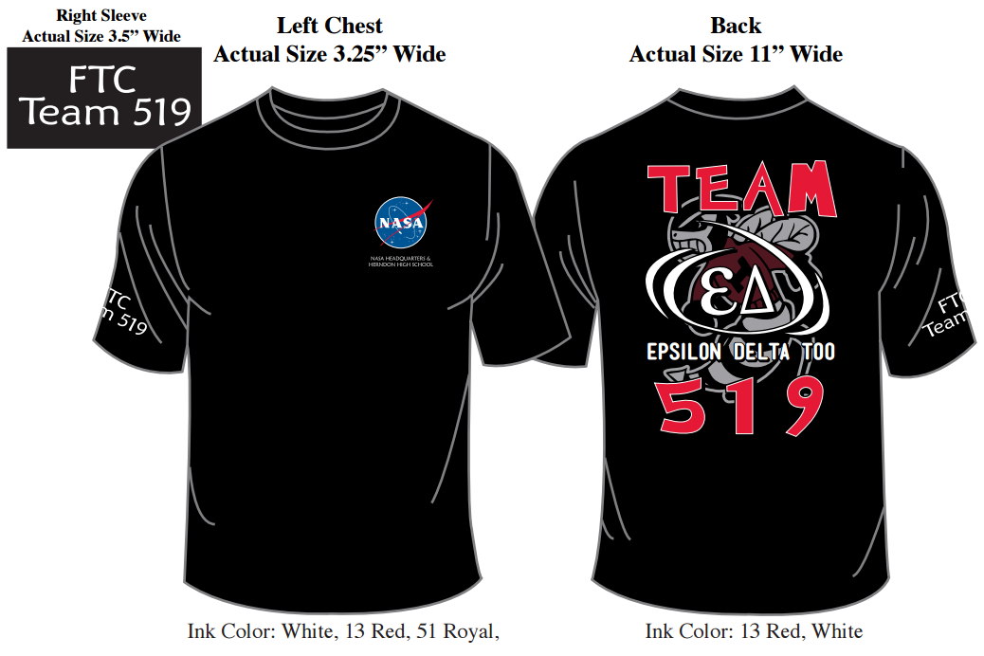
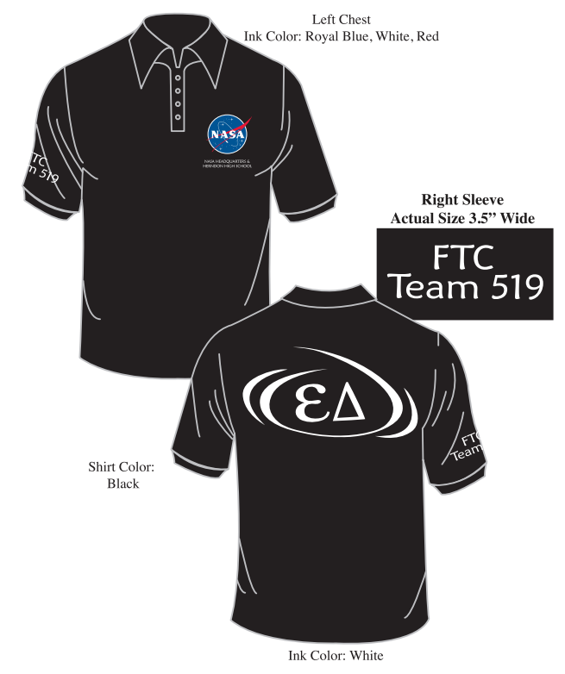
Students will receive team polo shirts and are expected to wear them to all formal competitions, scrimmages, and outreach events, as well as team pictures. Team tee-shirts are to be worn at all informal events. The shirts proudly display NASA’s signature “meatball” logo which has been approved for us to wear. We are proud to partner with NASA and to represent them at many of the events that we are a part of. Other aspects of dress for tournaments should be appropriate, neat, and modest, and should adhere to workshop rules (no open toe shoes, no long dangling jewelry, etc., as this is a safety issue in the pits.). For build meetings the student should wear appropriate, comfortable, neat clothing that does not present a work hazard or distraction. Shirts can be purchased from Reston Shirt & Graphic Co., Inc. 341 Victory Drive, Herndon, VA 20170, 703-318-4802, RestonShirt.com

Safety
The responsibility of safety lies with each and every member of Herndon HS Robotics. Each team member is required to abide by safety rules at all times.
ALL STUDENTS MUST COMPLETE SHOP TRAINING YEARLY AND SUBMIT AN EMERGENCY CARE FORM.

Important safety rules include (but are not limited to):
- No open toe shoes, "Crocs", etc. Shoes provide important protection in case of dropped tools or materials. No loose-fitting clothing, dangling jewelry, or other items that present an entanglement hazard around equipment.
- No “horsing around." Work with tools and machines and do not mix with practical jokes or foolish behavior.
- No personal electronics with earphones-you need to be able to hear warnings or instructions from the mentors and other students.
- Always disable the robot’s "kill switch” or remove the battery before undertaking repairs or modifications.
- Use common sense. Be aware of what is going on around you.

Robotics Workshop
Team members will primarily work in the Herndon HS Drama room, Machine shop, and the Health room, designated for use by both robotics teams. All areas must be cleaned and chairs and tables restored to their original configurations at the conclusion of every meeting. This is everyone’s responsibility. It is also important to keep track of time and use the facilities in the time frame allotted. For use of any room or shop at Herndon HS, prior permission is required.

Tool Usage
The use of power tools is a necessity for most members of the team. Tools should always be used in a safe manner. Only adequately trained team members may use tools -no exceptions. Always remember that tool usage is a privilege and not a right, so use them responsibly. Talking to a mentor before using a tool is required. When using tools, a student is responsible to ensure everyone near them is wearing safety glasses and is paying attention, that there is adequate space, an uncluttered work area, and other common-sense precautions.

Computer and Software Use
Students are encouraged to bring personal laptops for digital work, or to load their own copies of software to be used during the season. FIRST provides students with free use of Professional 3-D modeling, CAD (computer-aided design) and programming software including tutorials.

Students are encouraged to learn as much about this software even if they do not intend on working in the engineering field in the future. The knowledge they gain can only enhance any of their future endeavors given that they are part of an ever-increasing digital generation.

Transportation
Transportation to and from meetings, competitions and scrimmages is the responsibility of each individual student. Robot team meetings are held both after school and on weekends. The schedule is communicated via email by the Administration Captain. For FTC, most meetings are 2 to 3 hours long, but near tournament time build meetings may be longer than normal. Not every student is expected to attend every meeting, and homework should be brought to the meetings and can be worked on during "down time" when the student's subsystem cannot be worked on.
Students must ensure their parents arrive to pick them up on time when meetings and events end.

Behavior
Herndon HS Robotics treats each student member as a respected young adult. Each student is expected to be respectful of all team members as well as other individuals that the team comes in contact with. Professionalism is a must from each student. Students are also expected to adhere to all Herndon HS and FCPS rules of conduct at all times, whether at build sessions, tournaments, outreach events, or any event where the student represents Herndon HS.

Cell Phones
Cell phone usage during meetings should only be for serious purposes related to the robotics team, such as informing a parent of a schedule change that requires an earlier or later pickup time, etc. During build sessions students should not be texting, talking on the phone socially, playing handheld games or other activities not related to the robotics team. If a student has "down time" waiting for some other team to complete a task before they can proceed, they should either work on related activities (fund raising, organizing the workshop) or homework they have brought to the meeting.

Food and Drinks
Because of long hours during build season some reasonable food and drink consumption is allowable in the work area, but cleanup is the responsibility of each student and food or drinks should not be consumed near machinery, computers or other places where it may represent a hazard.

Disciplinary Actions
Violation of Herndon HS rules of conduct, safety rule violations, or other inappropriate activity may result in suspension or even ejection from the Herndon HS Robotics Team, at the discretion of the mentors and in consultation with faculty advisors on a case by case basis.

Health Information
If any student has any health issue that the mentors should be aware of it should be brought to their attention by the student's parents.

Financial/Fundraising
Team 116 and 519 has been graciously sponsored by NASA Headquarters, Herndon HS, and many more. Because of these generous grants, we do not have to put lots of time into fundraising. However, we will be fundraising for extra team expenses and student expenses. Students should recognize what an enormous privilege this is and should always look to prepare a thank you gift at the end of the year.
Students are only required to pay for their lunch and in some cases transportation, at and to events.
In the event the team qualifies for the World Championship, the student is responsible for travel, food, and lodging expenses in connection with the event. Members of the team will at this time be involved in fundraising activities. This may include anything from making presentations for potential sponsors, to making phone calls, to writing thank-you letters to sponsors or demonstrating the robots to the community at large to offset travel costs. Although it is not required, the team will fundraise to cover extra team expenses and student expenses.

Student Involvement
The Herndon HS Robotics Team is a challenging activity that goes well beyond a typical high school club. There is a tremendous amount of information to learn and many skills our team members must quickly acquire. We are competing at the highest levels in state competitions, and in some recent seasons have even qualified to compete against the top teams in the world, an honor that only a small percentage of teams achieve. For this reason, significant commitment is required from our students. Just showing up at meetings is not enough to create a successful team at this level of competition. Students must have an excellent attendance record at build meetings and competitions, but more than that, they must strive to achieve real results at each meeting, and constantly explore ways to improve the robot and the team itself in a proactive manner. Students will frequently not be told what to do; rather they are expected to figure out what to do themselves, perhaps with some guidance and teaching from the mentors or captains.

Parent Involvement
Parents are invited to visit any build session, outreach event, or competition to observe the activities of the Herndon HS Robotics Team at any time. Parents are also encouraged to be on the email list the coach/ mentors use to communicate with students so they are fully informed of all activities. During our Saturday meetings, parents will be asked on occasion to provide lunch for the team.
Parents who wish to take a more active role in the team, which would bring them in closer contact with students besides their own, must satisfy several clearance requirements, and submission of information and finger prints for background checks.
All mentors have already been certified under these rules, which are the same for any club or activity at Herndon HS and are in place to protect every student. It is not difficult or overly time consuming to meet these requirements, and if you ever want to take an active role in any team, activity, or club at Herndon HS we encourage you to take these steps to become certified. For more information on precisely how to become certified please contact our teacher sponsor.

Conclusion
Herndon High School has an extensive robotics program that extends from 9-12 grades in high school. It is at the time of writing, currently restricted to only Herndon HS students. In this program, volunteer mentors with engineering and mechanical backgrounds, as well as nontechnical mentors in supporting roles, guide and teach the students real world engineering and organizational concepts. The students then apply those principles to develop a highly sophisticated robot including mechanical systems, electrical systems, sensors and feedback systems, etc. They then develop software to control the robot in complex ways, and finally they use the robot to compete against other top teams in our region and sometimes nationally. If that were not enough, students support community service and outreach activities, maintain professional quality engineering notebooks, and learn to speak to the press, judges at competitions, and sponsors. No other high school level activity offers such a rich learning experience, and many colleges and universities recognize this by offering scholarships and highly valuing robotics experience on application resumes.

I acknowledge that I have read, understand and agree to abide by the rules set forth in this Team 519 handbook.

Student Name ________________________________________________
Student Signature ______________________________________________
Student Telephone Number______________________________________
Student’s Email Address _________________________________________

Parent Name _______________________________________________
Parent’s Signature ____________________________________________
Parent’s Telephone Number ___________________________________
Parent’s Email Address _______________________________________

Please submit to Administrative Captain for record.

